Index Change Advice  www.ftse.com  www.ftsejse.co.za | 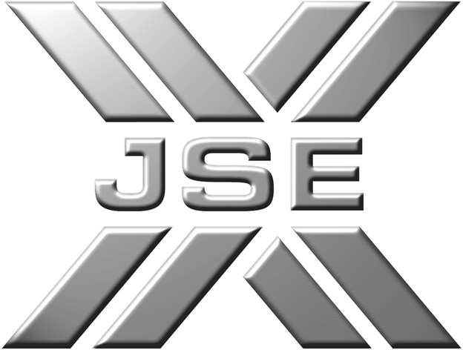

SA Mineral Resources (South Africa) : Shares in Issue Update

FTSE / JSE Africa Index Series
3 October 2002

Following the conversion of debt for equity in a related party transaction and notification from the Stock Exchange, FTSE and the JSE announces the following changes:

INDEX | CHANGE | EFFECTIVE FROM START OF TRADING
FTSE/JSE Africa Venture Capital | SA Mineral Resources (South Africa 6566830) will remain in the index with an increased shares in issue figure of 374,274,923 and an unchanged investibility weight of 50%. | 8 October 2002

For FTSE / JSE index enquiries or further information about FTSE / JSE please contact:
Client Services in UK: Tel: +44 (0) 20 7448 1810 and
Client Services in US: Tel: +1 212 825 1328 or +1 415 445 5660 and
Client Services in Asia Pacific Tel: +852 2230 5800 or +65 223 3738.
JSE Securities Exchange South Africa Tel: (27 11) 520 7702 or +520 7777

Or, email your enquiries to info@ftse.com, indices@jse.co.za or visit our websites www.ftse.com or www.ftsejse.co.za

