Market Notice

Number: | A1154
Date: | 4 December 2009

COMMODITY DERIVATIVE MARKET – RESTORATION OF JSE’S NETWORK ENVIRONMENT
Service (s):

- TradElect and InfoWiz
- BDA
- Dissemination

Environment(s):

- Production

Additional Information:

Contact:

For further information please contact Customer Support:

011 520 7777 or email
Customersupport@jse.co.za

In light of the connectivity issues experienced on Monday, 30 November 2009 (Service Notice GEN 06/09) the JSE would like to restore the JSE’s network environment as at Friday, 27 November 2009. The JSE would like to implement the changes tomorrow Saturday, 5 December 2009, in preparation for the Futures Closeout on Thursday, 17 December 2009.

Clients are therefore requested to connect to the following JSE services to test connectivity:
- Equity Market Trading
  - From 09h00 - JSE connectivity test (Telnet tests)
  - From 11h30 - Connect to SII (JSE TradElect)
  - From 11h30 - Connect to IRI (JSE InfoWiz)
  - From 11h30 - Confirm receipt of Multicast Data (MC) on all Broadcast Data Groups (BDGs)
- BDA
  - From 09h00 – confirm login and one BDA dissemination download

- Equity Dissemination
  - From 09h00 – test the download of one file from Friday evening via FTP

The JSE team will be on site from 09h00 to assist clients with the tests and will provide updates to key contacts via email and SMS. Client participation is scheduled from 09h00 – 16h00 (including any rollback activities required). Clients are therefore requested to be on site from 09h00 but no later than 11h00. Kindly notify Customer Support once you are on site and escalate any connectivity issues to Customer Support.

The JSE strongly recommends that all clients take this opportunity to test their connectivity post the changes to ensure no impact to business on Monday. The JSE would like to sincerely apologise for the short notification provided however due to the key Business event of Equity Futures Closeout in less than two weeks, we believe the necessary actions are required to ensure a successful closeout.

We would like to express our sincere thanks for your co-operation and understanding regarding this issue and would like to assure you of our best efforts and commitment in providing you with a stable reliable production environment.

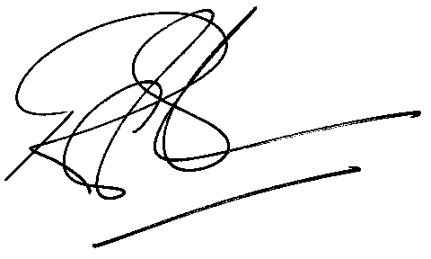

Rod Gravelet-Blondin
Designation | Senior General Manager
Division | Commodity Derivatives Division
Tel | +27 11 520 7258
Fax | +27 11 520 7558
E-mail address: | rodgb@jse.co.za

Distributed by the Company Secretariat +27 11 520 7591

