


AGRICULTURAL PRODUCTS DIVISION

28 August 2001 NOTICE A002

DELIVERY AND RECEIPT OF SAFEX SILO RECEIPTS

Please note the following:

- Notice of Delivery forms should be completed accurately and must be received by the Agricultural Products Division (APD) of the JSE before 12h30 on a normal trading day. In the case of extended trading hours for exceptional circumstances, the cut off time will be 30 minutes after the close of the market.

- Original Safex silo receipts must reach the APD before 12h00 on delivery day (the business day following the day on which notice of delivery was given.)

- Silo receipts may only be collected from the APD after 14h00 on delivery day.

- In order to facilitate logistics at the JSE Securities Exchange, delivery and receipt of silo receipts may only take place between 08h00 and 12h00 and between 14h00 and 16h00.

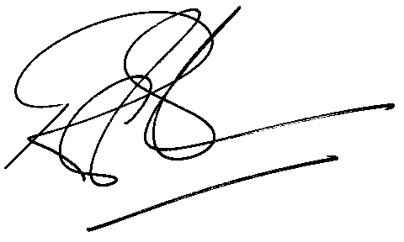

Rod Gravelet-Blondin

GENERAL MANAGER - AGRICULTURAL PRODUCTS DIVISION

