


AGRICULTURAL PRODUCTS DIVISION

29 August 2001 NOTICE A003

CHANGE IN MEMBER NAME

Please note that Protoil Commodity Services (Pty) Ltd. has changed their name to PCS Futures (Pty) Ltd. with immediate effect.

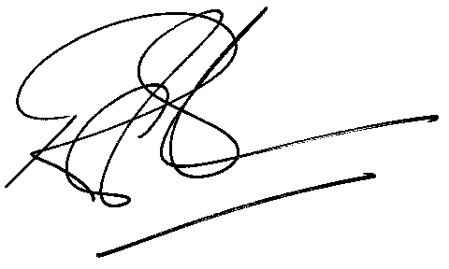

Rod Gravelet-Blondin

GENERAL MANAGER - AGRICULTURAL PRODUCTS DIVISION

