


AGRICULTURAL PRODUCTS DIVISION

11 September 2001 NOTICE A009

INCLUSION OF SILOS – WHITE MAIZE AND WHEAT FUTURES CONTRACT

The following silo and location differential has been included for the white maize and wheat futures contract.

The silo has been added to the list of delivery points from today onwards.

WHITE MAIZE FUTURES CONTRACT
Until 30 April 2002 From 1 May 2002

General Food Industries Ltd Isando -R30/t R34/t

WHEAT FUTURES CONTRACT
Until 30 Sep 2002 From 1 Oct 2002

General Food Industries Ltd Isando -R30/t -R34/t

INTRODUCTION OF NEW CONTRACTS FOR TRADING.

On Wednesday 19 September the following contracts will be listed for trading:
Sep2002 WMAZ, YMAZ and SUNS
Dec2002 WMAZ, YMAZ and SUNS

May2002 WEAT
Jul2002 WEAT
Sep2002 WEAT
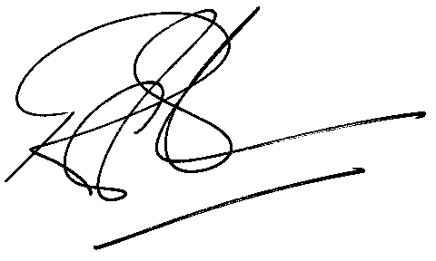
Rod Gravelet-Blondin

GENERAL MANAGER - AGRICULTURAL PRODUCTS DIVISION

