

JSE AGRICULTURAL PRODUCTS DIVISION NOTICE

NOTICE TO ALL MEMBERS NOTICE A077

9 April 2002

USE OF JSE/SAFEX NAME AND LOGO

The JSE has developed and owns a number of trade marks, including the logo shown above, the Safex logo incorporating the JSE logo, the names “the JSE” and “Safex”, “InfoWiz”, “JSE SETS”, “Talx”, etc.

Members are reminded that they may not use any of the JSE’s trade marks including but not restricted to in publicity, promotional or advertising material or on professional stationery, name plates or office premises, without the JSE’s express permission.

A member may record the fact that it is a “member of the JSE” or “a member of the Agricultural Products Division and or Financial Derivatives Division of the JSE” as the case may be, without infringing the JSE’s intellectual property rights.

If you have any queries about this notice, please feel free to contact the JSE’s Legal Division.

This notice is applicable to all members of the JSE’s equities, financial derivatives and agricultural products markets.

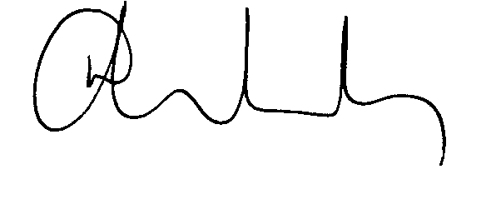
N NEWTON-KING
GENERAL COUNSEL

