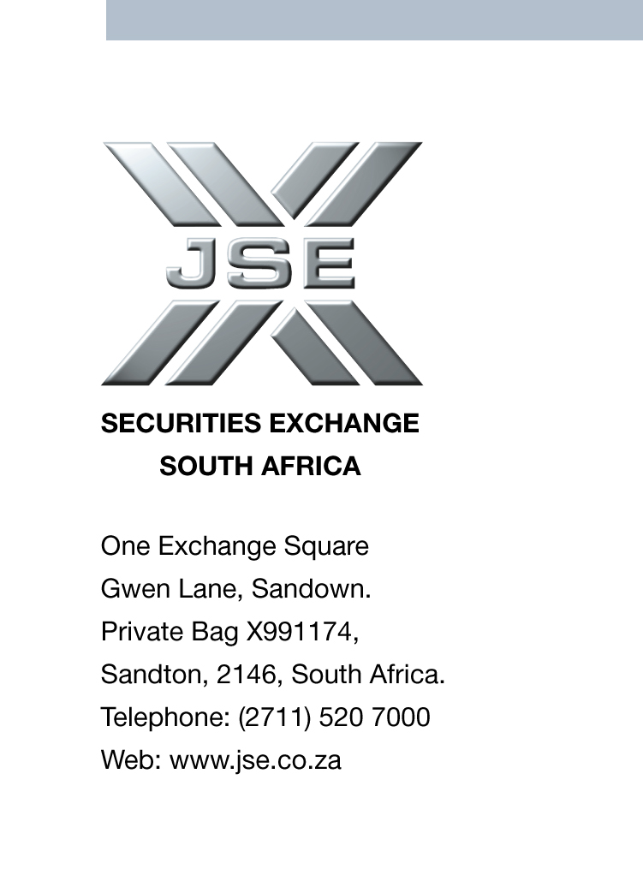


JSE AGRICULTURAL PRODUCTS DIVISION NOTICE

NOTICE TO ALL MEMBERS NOTICE A085

30 April 2002

CALCULATION OF OPTION VOLATILITIES AND THE INTRODUCTION
OF THE DELTA OPTIONS TRADING FACILITY ON THE ATS

After requests from the market it was discussed and agreed by the JSE EXCO and Agricultural Products Advisory Committee to activate the delta options trading facility on the ATS. Please note that both options trading facilities will be available to the market – options can be traded on price or volatility.

The facility to trade options on volatility has existed for some time and is accessible without any upgrade. A detailed explanation on the functionality on the ATS is attached to this notice.

The options mark-to-market procedure will be adjusted to include volatility traded options and will be calculated as follows:

The m-t-m volatility will be determined using options traded on price and volatility. The methodology for calculating the m-t-m will be as follows:

- Options traded at the money over the last half hour of trading will be considered at the discretion of the exchange
- The basis for calculating the futures m-t-m will remain unchanged
- Two strike prices (50 points) either side of the option at the money will be considered
- The direction of the market will be taken into consideration to determine if the puts or the calls receive a greater weighting
- The exchange reserves the right to make the final decision regarding the m-t-m volatility

The use of the delta trading facility together with the above m-t-m procedure will take effect as from Monday 6 May 2002.

All queries can be directed to the Agricultural Products Division

Rod Gravelet-Blondin
GENERAL MANAGER:AGRICULTURAL PRODUCTS DIVISION

DELTA OPTION TRADING

The following practical information is provided to assist members with the functionality of the ATS as regards delta option trading.

Delta hedging is a technique used by options traders to protect themselves against movements in the price of the underlying futures contract. The hedge ratio or delta is used to determine the number of futures to be bought or sold in order to hedge the exposure on the options contracts traded. The allocation of futures contracts when trading volatility is not optional as the system allocates them automatically according to the hedge ratio/delta.

DELTA = CHANGE IN VALUE OF OPTION
CHANGE IN PRICE OF UNDERLYING FUTURE

Delta varies between 0 and 1. A deep in-the money option has a delta close to 1, as it is likely to be exercised; whereas a deep out-of-the-money option has a delta close to 0. Delta hedging is calculated on a model that takes into account changes in the futures price, time to expiry and the difference between the strike and the futures price. For a call option, delta decreases as the price of the underlying futures contract decreases, whereas with a put, delta increases as the price of the underlying decreases. Therefore a call option has a positive delta and a put option has a negative delta. As the delta changes, the option trader will buy or sell futures contracts accordingly, therefore hedging his portfolio and leaving total exposure unchanged.

For example, if the delta = 0.7, for each call option sold, 0.7 futures contracts would be needed to hedge the portfolio. Therefore, if 10 call options are sold and 7 futures contracts are bought, according to the delta calculation, a R1 increase in the price of the futures contract will result in an increase of R7 on the futures positions held.

This will offset the loss on the 10 options of 10 x R0.70 = R7. Therefore the option trader has hedged the portfolio by holding the required futures and options as dictated by the hedge ratio/delta

Delta Trading on the ATS screen

In order to enter a delta trade:
- On the Futures screen, right click on either the ‘Instrument’, ‘Bid’ or ‘Ask’ of the relevant contract.
- Select Delta
Or
- On the Toolbar, select Windows
- Select Delta

On the Delta screen, the toolbar will indicate the Futures contract on which the delta trade will take place. The normal bid and offers boxes will appear where either the volatility or the price of the option can be inserted.
The delta screen is split into two. The top half of the screen shows the relevant underlying futures contract. If there is both a bid and a ask on the futures screen, the midprice of these will be indicated. Should the bid or offer trade then the last traded price will be reflected as the midprice, however should either the bid or offer be suspended and nothing trade, the midprice will continue to reflect the middle of the double. The midprice is the price at which the delta will be calculated, and will be the price at which the futures contracts required to fulfill the delta hedge will be traded. Futures may trade at a price that is not in 20cent intervals ie R1585.50.

The lower screen split shows the option leg of the delta trade and gives an indication of the last volatility at which a delta option was traded. PLEASE NOTE WHEN YOU TRADE IN THIS INSTRUMENT YOU WILL AUTOMATICALLY RECEIVE THE DELTA EQUIVALENT FUTURES CONTRACTS. The delta will be calculated as per the black options model.

To enter a trade, click on either Bid(C) or Ask(C) for a call option, or Bid(P) or Ask(P) for a put option. The trade is entered in the same way as a standard option, but now the required volatility can be entered instead of the price. Once the option trade is matched, the system will automatically allocate the delta equivalent number of futures at the midprice as indicated in the options window.
:
The delta option trades will have the following code format: eg. JUL02DYMAZ 1440 C in the global options window. The global option window will sort between options traded on price and volatility.

In View: Completed Orders
Only the Options leg (the order actually entered on the screen) will be shown. The futures allocated by the delta trade will not be shown. The Rate and Vol/Rte is shown as the volatility at which the delta option traded.

In View: Active Orders:
The delta option trade will have the same format as in completed orders
(eg. JUL02DYMAZ 1440 C), and the Rate shown is the Volatility at which the delta option traded.

The depth window will show the delta option contract as for the above
(eg. JUL02DYMAZ 1440 C)

On the Futures screen:
The futures leg of a delta trade will not show in the high or low column of the screen, only the Vol(ume) traded will increase.

In Views: Deals/Allocate:
The Delta trade is not distinguishable from other trades, and will be shown as standard options and futures contracts.

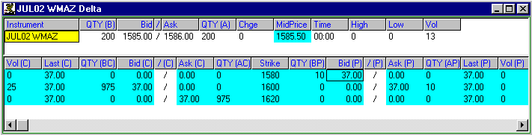

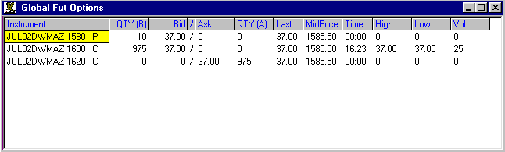

The following general rules will apply to delta trades:
- The required number of futures for the option being traded is calculated by multiplying the number of options by the delta of the option
- The futures price will be the midprice indicated in the option windows
- The number of futures positions received will be rounded according to the number of contracts traded as per the delta
- The seller of a put option will automatically sell this number of futures to hedge the option sale, and vice versa for the buyer of a put option
- The seller of a call option will automatically buy the required number of futures contracts to hedge their exposure, and vice versa for the buyer of a call option
- Once the initial delta hedge has been completed, the seller of both put and call options must progressively buy futures when the price of the underlying future increases, and sell futures when the price is falling in order to keep their portfolio hedged, and remain delta neutral.
- The reverse is true for option buyers, who will progressively sell futures as calls move further in-the-money, and puts move further out-of-the-money

The following scenarios illustrate the number of futures allocated for various option trades on the delta screen

MAY02DYMAZ 1440 Call option
On 09/04/2002 at a Volatility of 32.00

1) Futures price = R1,700.00
Delta = 0.995

No. of options traded | No. of futures allocated
1 | 0
10 | 9
100 | 100
1000 | 995
27 | 26

2) Futures price = R1,437.00
Delta = 0.500

No. of options traded | No. of futures allocated
1 | 0
10 | 5
100 | 50
1000 | 500
27 | 13

3) Futures price = R1,371.00
Delta = 0.226

No. of options traded | No. of futures allocated
1 | 0
10 | 2
100 | 23
1000 | 226
27 | 6

MAY02DYMAZ 1440 Put option
On 09/04/2002 at a Volatility of 32.00

1) Futures price = R1,508.80
Delta = -0.226

No. of options traded | No. of futures allocated
1 | 0
10 | 2
100 | 22
1000 | 226
27 | 5

2) Futures price = R1,437.00
Delta = -0.500

No. of options traded | No. of futures allocated
1 | 0
10 | 5
100 | 50
1000 | 500
27 | 13

3) Futures price = R1,373.80
Delta = -0.756

No. of options traded | No. of futures allocated
1 | 0
10 | 7
100 | 76
1000 | 756
27 | 20

Members are once again reminded that should they trade a delta option that a delta equivalent futures contracts will be allocated to the trade. Please do not hesitate to contact the Agricultural Products Division before executing a trade should any clarification on the planned trade be required.

