


JSE AGRICULTURAL PRODUCTS DIVISION

NOTICE TO ALL MEMBERS NOTICE A089

23 May 2002

TRANSFER OF OWNERSHIP AND INCLUSION OF SILOS

MAIZE,WHEAT AND SUNFLOWER SEEDS

The following silo and location differential has been included for the white and yellow maize futures contract.

The silo has been added to the list of delivery points with immediate effect.

MAIZE FUTURES CONTRACT
Silo owner Silo Location differential

OTK Bethlehem -R75/t

Pretoria West silo
Ownership of Pretoria West silo has changed from Premier Foods to MGK Operating Company (PTY) Ltd, the silo will remain listed as a registered delivery point on Safex for maize and wheat deliveries, and has also being registered for sunflower seed deliveries .

Silo owner Silo Sunflower location differential
MGK Pretoria West -R67/t

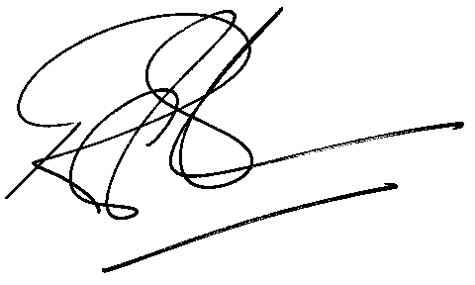

Rod Gravelet-Blondin

GENERAL MANAGER: AGRICULTURAL MARKETS DIVISION

