


JSE AGRICULTURAL PRODUCTS DIVISION

NOTICE TO ALL MEMBERS NOTICE A100

28 June 2002

ORIGINS OF DELIVERABLE MAIZE ON THE

JSE SECURITIES EXCHANGE (JSE)

The agricultural futures market in South Africa was established in 1995 following the deregulation of price control in the agricultural market and has provided all market participants with a much needed and well proven price risk management mechanism. The operation of the market has drawn substantial support from the grains industry in South Africa and warm applause within South Africa and internationally. The futures market has ensured that the price of grain in South Africa reflects market fundamentals of domestic demand and supply, regional demand and supply, and import and export parity pricing. It has afforded market participants the opportunity to hedge the risk of adverse price movements. Participants, particularly end users, could have secured white maize for delivery in early 2002 during the last six months of 2001 at levels below R1100 per ton. The fact that the price risk management mechanisms provided by the futures market were not fully utilised during that period exacerbated the demand for the physical product. This thereby contributed in part to the upward pressure on the maize prices experienced during recent months.

The fundamental basis on which futures contracts are traded is the standardisation of all variables, including quality, in order that the product can be traded on a price only basis. When the white and yellow maize contracts were introduced in early 1996, the quality standardisation that was agreed in consultation with market participants was South African grades WM1 (white maize grade one) and YM1 (yellow maize grade one) respectively. It was also agreed that only maize of African origin would be permitted to be delivered in completion of a futures contract. The reason for this was to encourage regional participation in the market where possible, and because it was considered that the quality of maize from other origins would not meet the required quality standards as laid down in the contracts.

Member of the World Federation of Exchanges
WORLD FEDERATION OF EXCHANGES' STATISTICS REVIEW ...

During the past several months, the JSE Agricultural Products Division (APD) Advisory Committee, consisting of participants selected from the agricultural industry, has been requested on several occasions by various participants in the market, to consider the possibility of changing the deliverable specification to permit maize of any origin which meets the required grading specifications of WM1 and YM1 to be delivered in completion of a futures contract. It was agreed not to proceed with such a change to the contract specifications without at first consulting the active members in the market, who in turn would consult with their clients. A discussion paper to this effect was distributed on Friday 21 June 2002 and a large number of reponses have been received.

The supply situation of maize in South Africa at present includes imported white and yellow maize from various origins. There is a strong view in the grains market that this situation should be accurately reflected in the futures market, on the proviso that the quality standards of maize delivered are not compromised.

The primary aim of a futures market is not necessarily physical delivery. However, physical delivery is permitted to ensure that the value of the futures contract correctly reflects the value of the underlying product. The issue faced by the JSE is one of ensuring that the futures contract traded correctly reflects the underlying commodity, ie that it is standardized and that market integrity is maintained. Under such conditions the price would correctly reflect the value of the underlying product. The JSE has surveillance mechanisms in place to monitor trading patterns and constantly reviews the open interest positions of all market participants. The discussion to review the origins of deliverable maize is not a matter of price levels or potential defaults. Rather, it is centered on the question of ensuring that the integrity of the maize futures contracts is not compromised by quality differences.

After careful consideration of all the factors related to the opening of the origin of maize, which can be delivered in completion of a Safex futures contract on the APD of the JSE and reviewing all the responses received from market participants in reply to the consultative paper sent to active market members, it has been decided to proceed as follows:

- In terms of the WMAZ (white maize) and YMAZ (yellow maize) contracts presently listed on the exchange which have open interest, maize of an African origin will remain the underlying product. Thus, only maize of African origin that conforms to the South African WM1 and YM1 grading standards may be delivered in completion of a Safex futures contract. Therefore, no change to the present specifications will be implemented.

- As from Monday 8 July 2002 the WSEC (white maize grade two )and YSEC (yellow maize grade two) contracts will be changed in name to WOPT (white maize optional origin) and YOPT (yellow maize optional origin)and September 02, December 02 and March 03 contracts will be listed. The underlying product for WOPT and YOPT contracts will be maize of optional origin which conforms to the South African WM2 and YM2 grading standards respectively. The origin of such maize would need to be clearly specified on

the Safex silo receipt by the silo owner and the product would need to be stored separately by an approved Safex silo owner in an approved Safex silo.

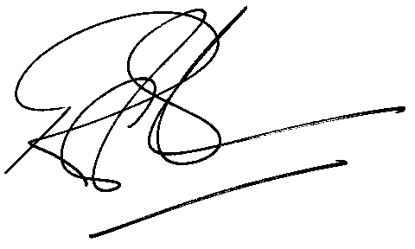

Rod Gravelet-Blondin

GENERAL MANAGER: AGRICULTURAL MARKETS DIVISION

