


JSE AGRICULTURAL PRODUCTS DIVISION

NOTICE TO ALL MEMBERS NOTICE A103

3 July 2002

INCLUSION OF SILO – MAIZE FUTURES CONTRACT

The following silo and location differential has been included for the white and yellow maize futures contract.

The silo has been added to the list of delivery points with immediate effect.

MAIZE FUTURES CONTRACT
Silo owner Silo Location differential

OTK Maizefield -R65/t

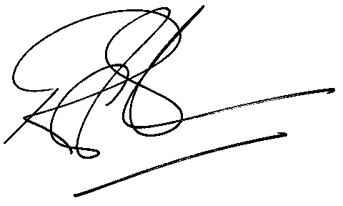

Rod Gravelet-Blondin

GENERAL MANAGER: AGRICULTURAL MARKETS DIVISION

