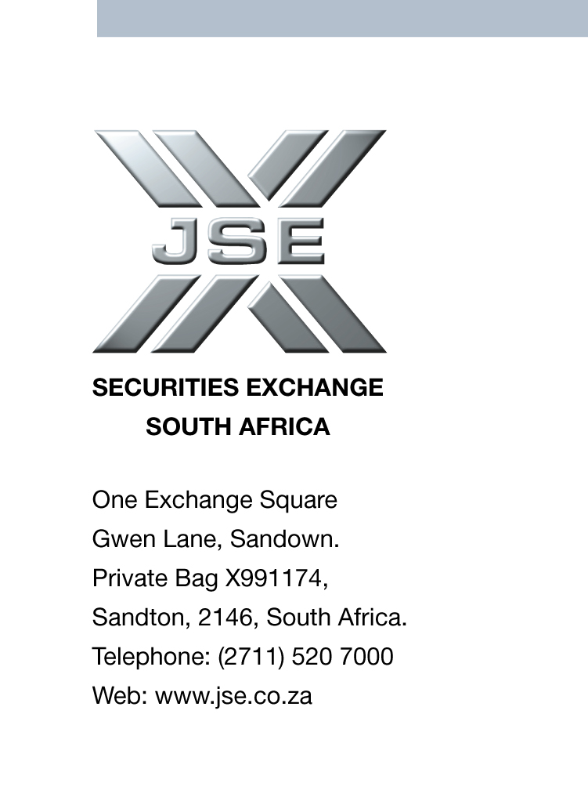


JSE AGRICULTURAL PRODUCTS MEMBERS

NOTICE TO ALL MEMBERS NOTICE A133

10 September 2002

NEW MEMBER

Having fulfilled all the requirements in terms of the derivatives rules of the JSE, the following company is hereby admitted as a broking and non-clearing financial derivatives member with immediate effect:

Unigrain (Pty) Ltd

Dealing code :UNG

Physical Address:
1 Mercedes Street
Aureus
Randfontein
1759

Postal Address:
P.O. Box 488
Randfontein
1760

Telephone no. :011 692-4400
Fax no. :011 692-4452

Proposed by :ABSA Bank Ltd

Seconded by: :PCS Futures (Pty) Ltd

The registered officer for the above member is:

B.R. Sinclair :Compliance Officer & APD Dealer

J.N. Janse van Rensburg :APD Dealer

J.J. Barnard :APD Dealer

Gary Clarke
COMPANY SECRETARY

