


JSE AGRICULTURAL PRODUCTS MEMBERS

NOTICE TO ALL MEMBERS NOTICE A135

20 September 2002

INCLUSION OF SILOS – WHEAT FUTURES CONTRACT

The following silos and location differentials have been included for the wheat futures contract.

The silos will be added to the list of registered delivery points as from 1 October 2002 with the differentials applicable for the period 1 Oct02 – 30 Nov03.

WHEAT FUTURES CONTRACT
Silo owner Silo Location differential

NWK Delareyville -R59/t Hibernia -R53/t Koster -R43/t

Please note that Hibernia silo has an additional R4.00 per ton INCLUDED in the differential to account for the extra transport costs used to link up with the Spoornet line.

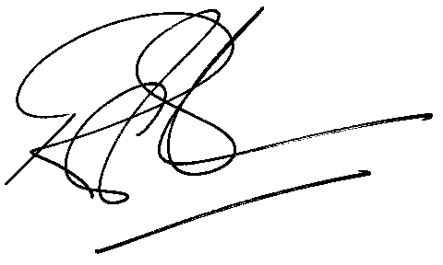

Rod Gravelet-Blondin

GENERAL MANAGER: AGRICULTURAL MARKETS DIVISION

