


JSE AGRICULTURAL PRODUCTS MEMBERS

NOTICE TO ALL MEMBERS NOTICE A139

1 October 2002

LOCATION DIFFERENTIALS AND STORAGE RATES FOR THE 2003/2004 SEASON

The location differentials applicable to delivery in completion of a futures contract were realigned on 3 August 2001 (AMD notice 383) for the period 1 May 2002 to 30 April 2003. It was agreed to introduce the May 2003 and July 2003 white and yellow maize contracts ( APD Notice A084 dated 30 April 2002) and the March 2003, May 2003 and July 2003 Suns contracts (APD Notice A084) without finalization of the standard storage rate and the location differentials.

A shift in the volumes of grain transported between rail vs road has necessitated a change in the methodology used to calculate the location differentials. In the past rail transport tariffs were primarily considered when calculating the differentials. An increase in the volumes of grain transported by road has resulted in the JSE increasing the percentage of the road transport costs in the calculation of the differentials for the 2003/2004 marketing season. The differentials serve to provide an indication of the cost to transport product from the indicated silo to Randfontein. Due to the nature of transport costs within a market economy, the Safex location differentials are neither definitive nor prescriptive.

After a thorough investigation which included consultation with various participants in the market, and taking into account the actual increase in all transport tariffs in 2002, the envisaged increases in 2003, and the inclusion of the higher road transport costs, the JSE have decided that the location differentials applicable on the delivery of product in fulfilment of a Safex futures contract will be as indicated in the attachment. The following differentials will be applicable for white and yellow maize for the period 1 May 2003 to 30 April 2004 and for sunflower seeds for the period 1 February 2003 to 31 January 2004.

The standard storage rates will be as follows:
Maize Futures Contracts:
1 May 2002 – 30 April 2003 28c/t/day
1 May 2003 – 30 April 2004 31c/t/day

Sunflower Seeds Futures Contracts:
1 May 2002 – 31 January 2003 56c/t/day
1 February 2003 – 31 January 2004 62c/t/day

Soybeans Futures Contracts:
1 January 2002 – 31 December 2002 30c/t/day
1 January 2003 – 31 December 2003 32c/t/day

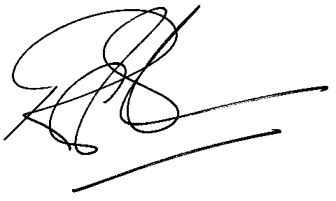

Rod Gravelet-Blondin
GENERAL MANAGER: AGRICULTURAL MARKETS DIVISION

