


JSE AGRICULTURAL PRODUCTS MEMBERS

NOTICE TO ALL MEMBERS NOTICE A143

7 October 2002

WHEAT CONSTANT MONTH CONTRACTS

As requested by the market, the wheat futures constant month contracts will be listed for the following months:

Futures Month Introduction date
November 2002 11/10/2002
January 2003 6/12/2002
February 2003 13/1/2003
April 2003 10/3/2003

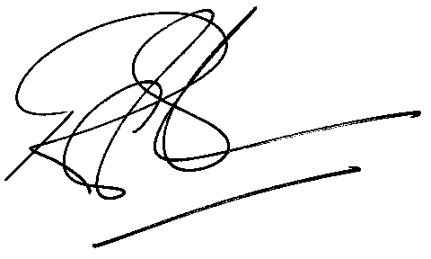

Rod Gravelet-Blondin
GENERAL MANAGER: AGRICULTURAL MARKETS DIVISION

