


JSE AGRICULTURAL PRODUCTS MEMBERS

NOTICE TO ALL MEMBERS NOTICE A157

25 October 2002

INCLUSION OF SILO OWNER AND INDIVIDUAL SILOS - NTK

The following silos and location differentials have been included for the white and yellow maize, wheat and sunflower seeds futures contract.

The silos will be added to the list of registered delivery points as from 31 October 2002 with the differentials applicable as per the different marketing seasons.

FUTURES CONTRACTS
Silo owner Silo Location differential
Maize Futures Contract
1/5/02-30/4/03 1/5/03-30/4/04

Noord-Transvaalse Alma -R72/t -R84/t

Kooperasie Bpk Lehau -R63/t -R74/t

(NTK) Naboomspruit -R71/t -R83/t
Nutfield -R70/t -R82/t Nylstroom -R68/t -R79/t
Potgietersrus -R77/t -R90/t
Roedtan -R75/t -R88/t
Settlers -R65/t -R76/t
Warmbad -R64/t -R75/t
Wheat Futures Contract
1/10/02-30/09/03

Noord-Transvaalse Alma -R72/t

Kooperasie Bpk Lehau -R63/t

(NTK) Naboomspruit -R71/t
Nutfield -R70/t Nylstroom -R68/t
Potgietersrus -R77/t
Roedtan -R75/t
Settlers -R65/t
Warmbad -R64/t
Sunflower Seeds Futures Contract
1/5/02-31/1/03 1/2/03-31/1/04

Noord-Transvaalse Alma -R100/t -R124/t

Kooperasie Bpk Lehau -R88/t -R110/t

(NTK) Naboomspruit -R99/t -R123/t
Nutfield -R98/t -R121/t
Nylstroom -R95/t -R117/t
Potgietersrus -R107/t -R133/t
Roedtan -R105/t -R130/t
Settlers -R91/t -R112/t
Warmbad -R89/t -R111/t

The contact details for Noord Transvaalse Kooperasie Bpk is as follows:
Contact person: Mr BA van Eck
Tel: 014 719 9741
Fax: 014 717 1693

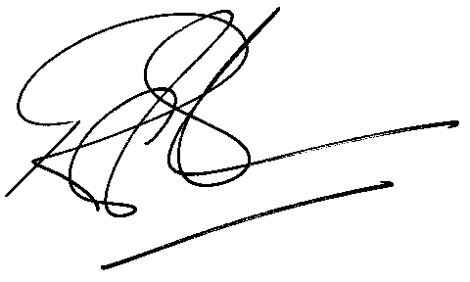

Rod Gravelet-Blondin

GENERAL MANAGER: AGRICULTURAL MARKETS DIVISION

