


JSE AGRICULTURAL PRODUCTS MEMBERS

NOTICE TO ALL MEMBERS NOTICE A160

31 October 2002
REFERENCE TO DERIVATIVES NOTICE A158

With reference to the rule changes per Derivatives Notice A158, all members are reminded that the provisions of these rules are now effective. Of particular importance to traders is new rule 7.139 that requires the use of the 4-digit sub account for all agency (i.e. non-balance sheet) activity on the ATS.

Members are required to open and operate, by the latest, Wednesday, 6 November 2002, the 4-digit sub accounts with numerical sequences beginning with 99, for the purposes of conducting agency activity on the ATS (i.e. members must use a/c number sequences from 9900 to 9999 or 99AA to 99ZZ exclusively for the purposes of conducting client activity on the ATS, or activity on behalf of other members.) Members are permitted to use any number of client sub accounts, provided these comply with the number sequences as described above. Members are not permitted to conduct any form of proprietary activity or enter proprietary orders on the ATS on the 4-digit sub account series beginning with 99.

In order to facilitate order entry and trade execution for clients or other members in terms of the above, these sub accounts may be loaded and ATS terminals may be set up by traders to default to their respective sub accounts through the Config / Secu Setup / Configuration / Set Limits / Solo Trader / Add Sub A/C menus on the ATS. Members are requested to contact Faeza Sallie (FPD) on 011-520 7489 or Chris Sturgess (APD) on 011-520 7299 should they require further assistance with the set up of these accounts.
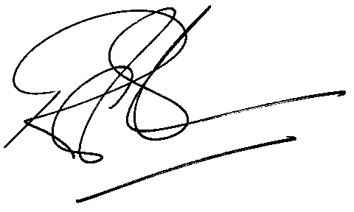
Rod Gravelet-Blondin

GENERAL MANAGER: AGRICULTURAL MARKETS DIVISION

