


JSE AGRICULTURAL PRODUCTS MEMBERS

NOTICE TO ALL MEMBERS NOTICE A166

1 November 2002

INCLUSION OF SILOS – WHEAT FUTURES CONTRACT

The following silos and location differentials have been included for the wheat futures contract.

The silos will be added to the list of registered delivery points with immediate effect.

WHEAT FUTURES CONTRACT
Silo owner Silo Location differential

1 Oct02 –30 Sep03

Senwes Attie -R59/t Heilbron -R52/t Vierfontein -R48/t
Wolwehoek -R38/t

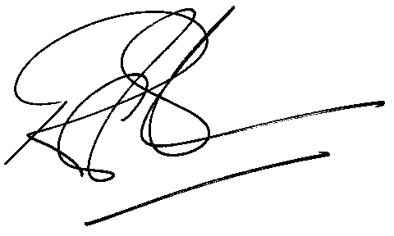

Rod Gravelet-Blondin

GENERAL MANAGER: AGRICULTURAL MARKETS DIVISION

