


JSE AGRICULTURAL PRODUCTS MEMBERS

NOTICE TO ALL MEMBERS NOTICE A191

18 December 2002

INCLUSION OF SILO – WHEAT FUTURES CONTRACT

The following silo and location differential has been included for the wheat futures contract.

The silos will be added to the list of registered delivery points with immediate effect.

WHEAT FUTURES CONTRACT
Silo owner Silo Location differential

1 Oct02 –30 Sep03
OTK Maizefield -R65/t

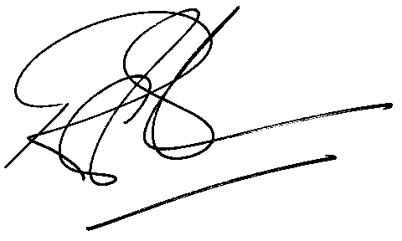

Rod Gravelet-Blondin

GENERAL MANAGER: AGRICULTURAL MARKETS DIVISION

