


JSE AGRICULTURAL PRODUCTS DIVISION

NUMBER: A198

DATE: 23 December 2002

CHANGES TO THE REGISTERED WHEAT SILOS FOR DELIVERY ON THE WHEAT FUTURES CONTRACT

The following silos and location differentials have been included for the wheat futures contract.

The silos will be added to the list of registered delivery points with immediate effect.

WHEAT FUTURES CONTRACT
Silo owner Silo Location differential

1 Oct02 –30 Sep03

OTK Leeuspruit -R47/t

VKB Vrede - -R67/t Tweeling -R60/t

Grootvlei silo will be deregistered as an approved delivery point for wheat with immediate effect.

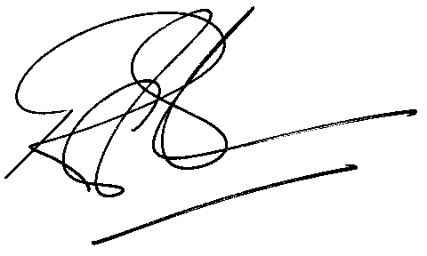

Rod Gravelet-Blondin

GENERAL MANAGER: AGRICULTURAL MARKETS DIVISION

