


JSE AGRICULTURAL PRODUCTS DIVISION

NUMBER: A199

DATE: 8 January 2003

NEW MEMBER

Having fulfilled all the requirements in terms of the derivatives rules, the following company is admitted as an agricultural products member of the JSE with immediate effect:

RMB Securities (Pty) Ltd

Dealing Code :RSA

Physical Address:
1 Merchant Place
Cnr. Fredman Drive & Rivonia Road
Sandton
2196

Postal Address:
P.O. Box 786273
Sandton
2146

Telephone no. :011 269-9020
Fax no. :011 269-9591

Proposed by :Rand Merchant Bank, a Division of FirstRand
Bank Ltd

Seconded by :Applied Derivatives (Pty) Ltd

The registered officers for the above member are :
M.J. Lambert :Compliance Officer

R. Humphreys :Alternate Compliance Officer

C. Kenmuir :APD Dealer

P. du Plessis :APD Dealer

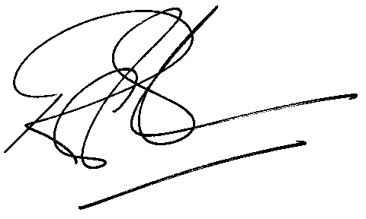

Rod Gravelet-Blondin
GENERAL MANAGER : AGRICULTURAL PRODUCTS DIVISION

