


JSE AGRICULTURAL PRODUCTS DIVISION

NUMBER: A200

DATE: 8 January 2003

NEW MEMBER

Having fulfilled all the requirements in terms of the derivatives rules, the following company is admitted as an agricultural products member of the JSE with immediate effect:

DWT Securities (Pty) Ltd

Dealing Code :DWT

Physical Address:
Unit 1, Mountain View Office Park
Bella Rosa Street
Rosenpark
Durbanville
7550

Postal Address:
P.O. Box 4435
Tygervalley
7536

Telephone no. :021 914-6460
Fax no. :021 914-6458

Proposed by :ABSA Bank Ltd

Seconded by :Futureline (Pty) Ltd

The registered officers for the above member are :

G.L.P. Trichardt :Compliance Officer & APD Dealer

H.A. de Waal :APD Dealer

P.J. Weideman :APD Dealer

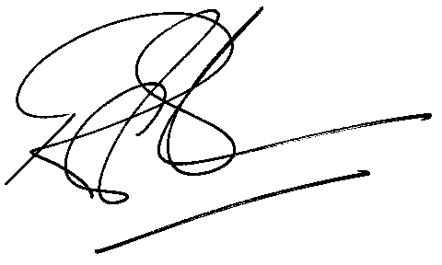

Rod Gravelet-Blondin
GENERAL MANAGER AGRICULTURAL PRODUCTS DIVISION

