


JSE AGRICULTURAL PRODUCTS DIVISION

NUMBER: A201

DATE: 8 January 2003

REGISTER OF OFFICERS

NEW OFFICERS:
Please note the following additions to the Register of Officers with immediate effect:

G.S. van Os PCS Futures (Pty) Ltd APD Dealer

W.H. van Zyl Commodity House (Pty) Ltd APD Dealer

CHANGES:
Please note the following changes to the Register of Officers with immediate effect:

C. Dorning from Deel-Smith Securities (Pty) Ltd Compliance
to PCS Futures (Pty) Ltd Officer

B.M. Griesel from BOE Bank Ltd to Nedbank Ltd APD Dealer

F.J.L. Odendaal from B & P Group Financial Services APD Dealer
(Pty) Ltd to NWK Ltd

WITHDRAWALS:
Please note the following withdrawals from the Register of Officers with immediate effect:

A. Nel PCS Futures (Pty) Ltd APD Dealer

A. Smith NWK Bpk APD Dealer

J. Wiseman PCS Futures (Pty) Ltd Alternate
Compliance Officer &
APD Dealer

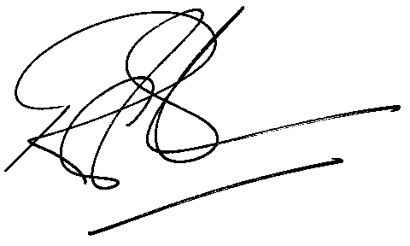

Rod Gravelet-Blondin
GENERAL MANAGER AGRICULTURAL PRODUCTS DIVISION

