


JSE AGRICULTURAL PRODUCTS DIVISION

NUMBER: A203

DATE: 17 January 2003

MARK-TO-MARKET PROCEDURE

Safex notices 22,26,34,110 and 361 refer.

In order to further improve the integrity of the agricultural derivatives market in South Africa it has been decided, following discussion in the Agricultural Products Division Advisory Committee, to use a value weighted average price as the basis for determination of the mark-to-market futures price where possible.

A distinction will be made between liquid and illiquid contracts on the trading day for the purpose of the determination of the mark-to-market. A contract will be considered to be liquid on the trading day if 100 or more contracts trade during the final 30 minutes of a trading session. If less than 100 contracts trade during the final 30 minutes of a trading session the contract will be considered as illiquid on the trading day.

The mark-to-market procedure for liquid contracts will be the volume weighted average price during the final 30 minutes of a trading session. This means that only traded prices will be taken into account when determining the mark-to-market for liquid contracts. Assignments, netoffs and corrections will not be considered as trades and will not be taken into account in the determination of liquidity.

The current mark-to-market procedure will remain in place for all illiquid contracts.

The above change to the mark-to-market procedure will be implemented as from Wednesday 22 January 2003.

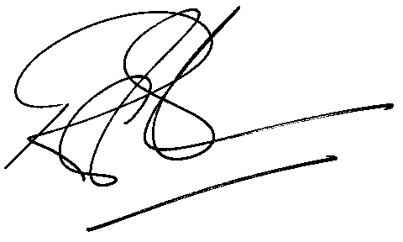

Rod Gravelet-Blondin
GENERAL MANAGER: AGRICULTURAL MARKETS DIVISION

