


JSE AGRICULTURAL PRODUCTS DIVISION

NUMBER: A208

DATE: 29 January 2003

PRICE LIMITS FOR THE WHEAT FUTURES CONTRACT

Price limits have never been adjusted for the wheat futures contract since the contract was first introduced in 1997. As the liquidity of the contract has increased and the value of the underlying commodity has changed, the exchange has decided to increase the price limits. This will be done in conjunction with an increase in the initial margin requirements. The price limit rule will read as follows:

If two or more like contracts (excluding the near month) trade at limits (up or down) for two consecutive days in the same direction, daily price limits will be extended from R45/t to R65/t, and will remain at extended limits until the daily price movement on all like contracts (excluding the near month) is equal to or below R45/t.

The initial margin will be increased for all open positions from R3000/contract to R5000/contract.
Initial margin on first notice day increase to R7500\contract
Initial margin on last trading day increase to R15000\contract
Calender spread margins increase to R1750\contract
VSR remains at 3.5

The above changes will be implemented as from Thursday 6 February 2003.

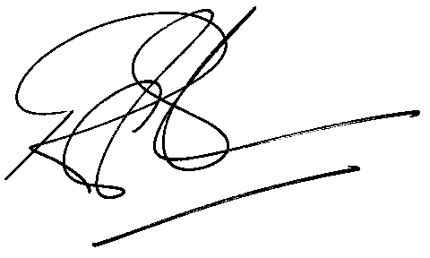

Rod Gravelet-Blondin
GENERAL MANAGER: AGRICULTURAL MARKETS DIVISION

