


JSE AGRICULTURAL PRODUCTS DIVISION

NUMBER: A214

DATE: 11 February 2003

DEREGISTERING ALL GWK SILOS FOR DELIVERY OF WHITE MAIZE

GWK LIMITED has requested that all their silos registered as white maize delivery points be removed from the list of Safex registered silos. These silos will remain registered for yellow maize deliveries. Please will members inform their clients of the above request and immediately notify the exchange should this result in any difficulties with current hedged positions.

Please report any objections to the deregistering to the exchange no later than Friday 28 February 2003.

A final notice will be distributed confirming that Douglas, Draghoender and Prieska silos will only be available for delivery of yellow maize if no objections are received.

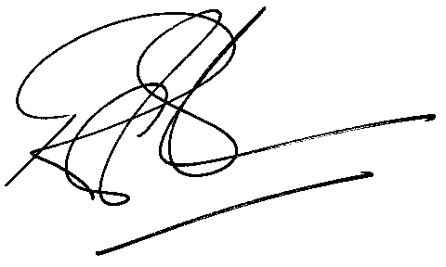

Rod Gravelet-Blondin
GENERAL MANAGER: AGRICULTURAL MARKETS DIVISION

