


JSE AGRICULTURAL PRODUCTS DIVISION

NUMBER: A227

DATE 11 March 2003

AGRICULTURAL PRODUCTS DIVISION ADVISORY COMMITTEE

REFERENCE TO NOTE A217

Notice A217 dated 14 February 2003 has reference.

Please note that Derek Matthews should be added to the Agricultural Products Advisory Committee. His name was inadvertently omitted from the list.

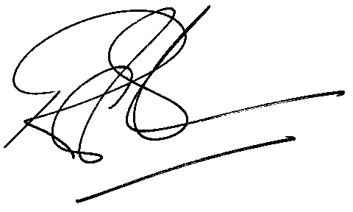
Rod Gravelet-Blondin
GENERAL MANAGER: AGRICULTURAL MARKETS DIVISION

