


JSE AGRICULTURAL PRODUCTS DIVISION

NUMBER: A247

DATE: 9 April 2003

NOTICE REGARDING THE WHEAT GRADE DISCOUNTS FOR THE 2003/2004 MARKETING

This serves to notify that the grade discounts indicated earlier, in APD notice A219 and A222, may change in due course. The par grade will remain as indicated, namely 12% protein and 77kg/hl specific weight. It is not standard practice for the exchange to change discounts once published, however due to the huge carry over stocks going into the new season and the difficulty in handling the different grade discounts between old and new season product, it may be necessary to do so. The issue has been recognised as a wheat industry problem and the exchange will try facilitating this issue with the role players who were involved in finalising the new grade, namely Grain South Africa, Grain Silo Industry and National Chamber of Milling, to resolve the problem as soon as possible. Please note therefore that the Dec03 and Mar04 contract will trade with no standardised grade discounts until further notice.

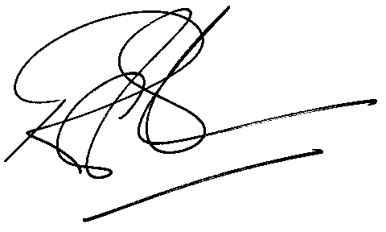

Rod Gravelet-Blondin
GENERAL MANAGER: AGRICULTURAL MARKETS DIVISION

