


JSE AGRICULTURAL PRODUCTS DIVISION

NUMBER: A248

DATE: 9 April 2003

MARK-TO-MARKET PROCEDURE

Safex notices 22,26,34,110, 361 and A203 refer.

Following on from a decision to use a value weighted average price (VWAP) as the basis for determination of the mark-to-market (mtm) for all liquid futures contracts, the process will be further refined during limit up or limit down price moves. If a specific expiry qualifies as a liquid contract in the last 30 minutes of trade, however should the market be bid limit up or offered limit down in the last 15 minutes with no trade taking place, the VWAP will be ignored and the contract will be mtm at the limit.

In the same way should the VWAP result in a mtm outside the daily price limits due to spread trades, the VWAP will be ignored and the expiry will be mtm at the price limit.

The above will be implemented with immediate effect. Please direct any questions to the Agricultural Products Division.

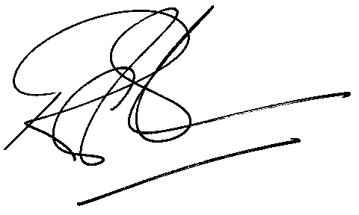

Rod Gravelet-Blondin
GENERAL MANAGER: AGRICULTURAL MARKETS DIVISION

