


JSE AGRICULTURAL PRODUCTS DIVISION

NUMBER: A256
DATE: 7 May 2003

CAPE WHEAT FUTURES CONTRACT

A notice was sent out to all active members on the 9 April requesting comments regarding the reintroduction of the cape wheat futures contract. The comments received indicate that the majority of the market is not in favour of the reintroduction. It has therefore been decided NOT to reintroduce the cape wheat futures contract at this point in time.

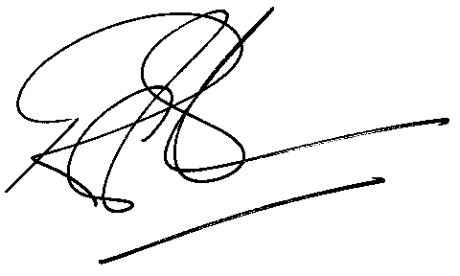
Rod Gravelet-Blondin
General Manager: Agricultural Products Division

