


JSE AGRICULTURAL PRODUCTS DIVISION

NUMBER: A257
DATE: 9 May 2003

DELIVERY OF WHEAT

Members take note that wheat, which is subject to Karnal Bunt protocol, will not be accepted for delivery in completion of a wheat futures contract.

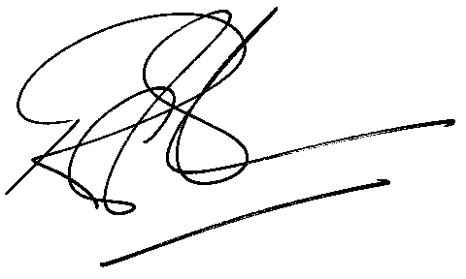
Rod Gravelet-Blondin
General Manager: Agricultural Products Division

