


JSE AGRICULTURAL PRODUCTS DIVISION

NUMBER: A258

DATE: 14 May 2003

CHANGES TO THE REGISTERED WHEAT SILOS FOR DELIVERY ON THE WHEAT FUTURES CONTRACT

The following silo and location differential have been included for the wheat futures contract.

The silo will be added to the list of registered delivery points with immediate effect.

WHEAT FUTURES CONTRACT

Silo owner Silo Location differential

1 Oct 2002 – 30 Sep 2003
SSK Heidelberg -R213/t

1 Oct 2003 – 30 Sep 2004
-R250/t

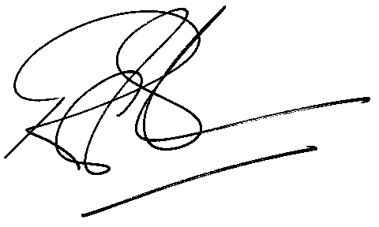

Rod Gravelet-Blondin

GENERAL MANAGER : AGRICULTURAL PRODUCTS DIVISION

