


JSE AGRICULTURAL PRODUCTS DIVISION

NUMBER: A267
DATE: 5 June 2003

EXCHANGE FOR PHYSICALS

Members are kindly reminded that the JSE can only do Exchange for Physicals (EFP) during the actual delivery month. EFP’s can be executed in two ways, either the positions can be netted off and the physical delivery transaction handled completely outside of the exchange or the JSE can facilitate the physical delivery by arranging payment and transfer of the silo receipts.

In order to transact an EFP both the long and short position holders must already have the existing futures positions. In the case where the JSE facilitates the delivery process, the notice by the short position holder must clearly identify that the delivery is an EFP and indicate who the long position holder is receiving the stock. If the long position holder identified on the notice of delivery does not hold a corresponding long position, the EFP will not be processed.

In both cases, the EFP takes place outside the random allocation procedure and as such the JSE will not change the storage date as reflected on the face of the receipt. If the JSE facilitates the delivery process the due Rand amount will be adjusted for any storage owing, but the JSE will not cancel prepaid storage as the EFP negates the need for standardisation.

All physical deliveries tendered for random allocation in completion of a futures contract which have prepaid storage will result in the seller not being reimbursed for the storage. The storage date will be cancelled by the JSE and changed to reflect the delivery date in order to ensure that all contracts delivered randomly through the exchange are standardised.

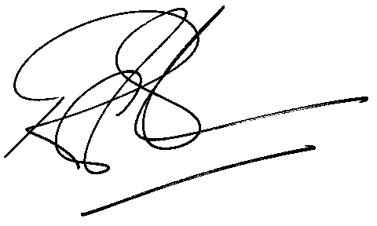
Rod Gravelet-Blondin
General Manager: Agricultural Products Division

