NOTICE TO ALL MEMBERS
NOTICE: A272

19 June 2003

INVITATION TO ATTEND A CONFIDENTIAL BRIEFING ON PROPOSED FINANCIAL SECTOR CHARTER

The process to develop a Charter for the financial services sector is well underway. The JSE has been participating in the process which is now at a stage where the JSE needs to make specific commitments on behalf of itself and its members in respect of the issues the Charter proposes to address.

We would very much like to present an overview of the Charter issues to all JSE members and get a mandate from members as to how to address these issues. You are accordingly invited to a confidential briefing on Tuesday, 24 June 2003 at 16h00 for an hour in the JSE auditorium. Please would you confirm whether or not you can attend with Jennifer Johnston on (011) 520 7022 or jenniferj@jse.co.za.

In view of the confidentiality of the Charter process, the JSE is only able to extend the invitation to attend the briefing to CEOs of the member firms. If you are not able to attend, please contact Nicky Newton-King on (011) 520 7010 or nickyn@jse.co.za or jenniferj@jse.co.za to discuss your firm's representation at the briefing.

Kind regards

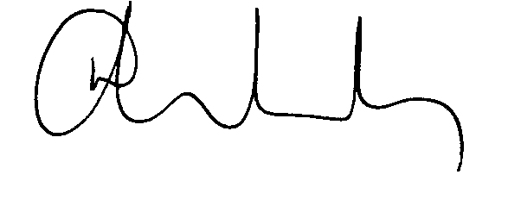

Nicky Newton-King
Deputy CEO

