


JSE AGRICULTURAL PRODUCTS DIVISION

NUMBER: A274
DATE: 25 June 2003

CONFIDENTIAL CEO BRIEFING ON FINANCIAL SECTOR CHARTER

Thank you very much to those who attended yesterday afternoon’s confidential briefing on the Financial Sector Charter. Russell and I tremendously much appreciated the discussion and the support shown for the JSE in this process.

We will, as agreed yesterday, proceed to participate in the Charter Task Group on behalf of the JSE and its members and in doing so will as far as possible advance the propositions we discussed yesterday.

Any member who has any concern about this approach or who was unable to attend yesterday’s briefing and who would like to discuss the Charter and the responses which we proposed to make on behalf of the JSE and its members, should please feel free to contact either Jennifer or myself urgently. We would be more than willing to discuss these issues further with you.

Jennifer Johnston Nicky Newton-King
(011) 520 7022 (011) 520 7010
jenniferj@jse.co.za nickyn@jse.co.za

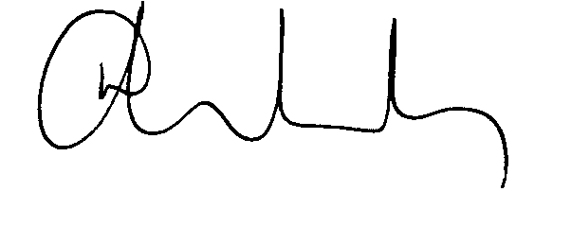

N NEWTON-KING
DEPUTY CEO

