


JSE AGRICULTURAL PRODUCTS DIVISION

NUMBER: A286
DATE: 21 July 2003

WHEAT GRADE DISCOUNTS FOR THE 2003/2004 MARKETING SEASON

Following from APD notices A219, A222 and A247 the wheat grade discounts have been finanlized for the 2003/2004 marketing season. In order to facilitate the large carry over of stock from the current season to the new season, a process has been agreed upon by GSI, GSA and NCM on behalf of the industry. The following wheat grading table will be applicable to all new season wheat stock as from I October 2003 for all Safex silo receipts:

GRADE B1 B2 B3
PROTEIN 12% min 11% min 10% min
SPECIFIC 77kg/hl min 76 kg/hl min 74 kg/hl min

WEIGHT
DISCOUNT PAR -R60.00 -R120.00

To accommodate the surplus old season stock, a dual delivery system will be maintained until 31 March 2004. All stock on the old season Safex silo receipts will be accepted as delivery in completion of a futures contract and will be subject to the old grade discounts as indicated below:

 | PROTEIN
SPECIFIC WEIGHT | 12 % + | 11.9 % - 10 %
> 79 kg\hl | PAR (BPS) | R100.00 discount (BSS)
76.0 – 78.9 kg\hl | R25.00 discount (BP1) | R125.00 discount (BS1)
74.0 – 75.9 kg\hl | R50.00 discount (BP2) | R150.00 discount (BS2)

Any old season stock which is tendered to the long position holder up to and included 31 March 2004, will have ten business days to negotiate out loading of the product with the silo owner under the old discounts. The product not out loaded within the due date and all other old season Safex silo receipts still in the market after 31 March 2004, will require that they be converted according to the new grading discounts in order to be valid for trading. The difference in value between the old grade and the new grade will be for the account of the current holder\owner of the Safex silo receipt.

The different grades will be converted as follows:

Old Grade New Grade
BPS B1
BP1 B2
BP2 B3
BSS B3
BS1 B3
BS2 B3

As from 1 April 2004 the JSE will only accept Safex silo receipts with the new grades as good delivery in completion of a futures contract.

Although silo owners will not be in a position to force any holders of old season stock to out load the product, the silo owners may CHARGE an additional administration fee for converting the Safex silo receipt according to the new grades. This fee will only be applicable to this specific wheat marketing season and only for old season stock, so as to facilitate the removal of old season product from the trading environment as soon as possible.

Please ensure that all clients are fully informed of this situation.

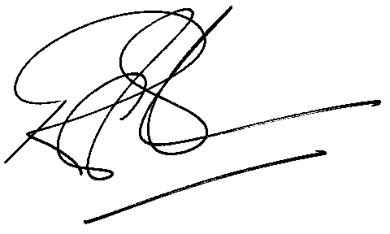
Rod Gravelet-Blondin
General Manager: Agricultural Products Division

