


JSE AGRICULTURAL PRODUCTS DIVISION

NUMBER: A288
DATE: 23 July 2003

SOYA BEAN FUTURES CONTRACT

The soya bean futures contract was introduced in April 2002 with four registered silos as delivery points, Vrede, Northam, Winterton and Bethal. The four delivery points all trade at the same basis price.

A proposal has been received to include Mkondo silo as a registered delivery point, making a total of five delivery points available to the market. To evenly spread the available delivery points and try improve the volumes traded, please will members consult with their clients to see if this meets with their approval as this will result in a change in the contract specifications. The JSE would like to introduce the Sep03, Dec03, Mar04, May04 and Jul04 contracts as soon as possible. Do members feel that all the trading months are necessary at this point ?

Please forward any comments or suggestions to the above proposal as soon as possible but no later than 31 July 2003 to chriss@jse.co.za

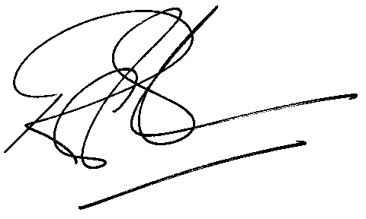
Rod Gravelet-Blondin
23 July 2003 General Manager: Agricultural Products Division

