


JSE AGRICULTURAL PRODUCTS DIVISION

NUMBER: A290
DATE: 1 August 2003

CONSTANT MONTH WHEAT FUTURES CONTRACT

To further assist with the price discovery of wheat in the cash market, a constant month wheat futures contract will be introduced on a continuous basis. The contract will trade as per the contract specifications for a constant month contract. Due to the late request from the market to continue with the constant month contract, no August contract will be introduced. The October 2003 constant month wheat futures contract will be introduced on 9 Sept 2003 for trading.

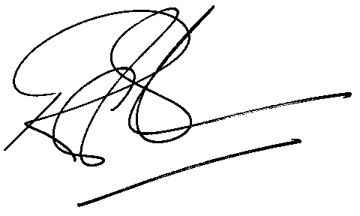
Rod Gravelet-Blondin
General Manager: Agricultural Products Division

