


JSE AGRICULTURAL PRODUCTS DIVISION

NUMBER: A291
DATE: 1 August 2003

STORAGE DATES ON SAFEX SILO RECEIPTS

Only authorized persons at the registered silo owner and the JSE Securities Exchange, are in a position to change the storage and handling date found on the Safex silo receipt. ANY changes made to the face of the silo receipt by any other person(s) is a criminal offence.

The storage and handling dates edited by the JSE will be accompanied with a JSE stamp and two signatures from authorized personnel at the JSE.

It is the members’ responsibility to ensure that changes to the storage and handling date on all Safex silo receipts are valid. This can be done by contacting the silo owner directly or if the JSE has changed the date, by contacting the APD to confirm the change. This verification process is especially important should there be more than one storage and handling date on the face of the silo receipt.

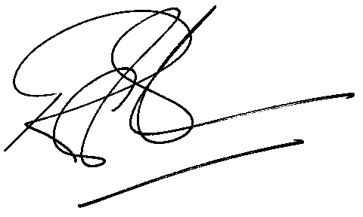
Rod Gravelet-Blondin
General Manager: Agricultural Products Division

