


JSE AGRICULTURAL PRODUCTS DIVISION

NUMBER: A292
DATE: 1 August 2003

SOYA BEAN FUTURES CONTRACT

Further to the replies received as per notice A288, Mkondo silo will be registered as the fifth delivery point for the soya bean futures contract together with Vrede, Northam, Winterton and Bethal. The delivery points will all trade at the same basis price.

The September 2003 and December 2003 contracts will be listed for trading on Monday 4 August 2003.

Following a discussion at the Agricultural Products Advisory Committee meeting, certain members felt that the liquidity on the soyabean contract would be benefited if the contract was changed to trade a central basis point with location differentials applicable to the different delivery points.

Originally, due to the size of the underlying soyabean crop in South Africa and difficulty in consistently calculating accurate location differentials, a method was chosen to trade a limited number of delivery points at the same basis price. The points chosen were representative of the different soyabean production areas and were agreed upon by the crushers.

Please could members consult with their clients, particularly those involved in trading soyabeans, to see if there is any support to change the current contract specifications. Any other comments or suggestions regarding the current contract specification, which may improve the liquidity, will be appreciated. Please forward all comments to the APD no later Friday 22 August 2003 so as to ensure that the new season contracts can be listed as soon as possible.
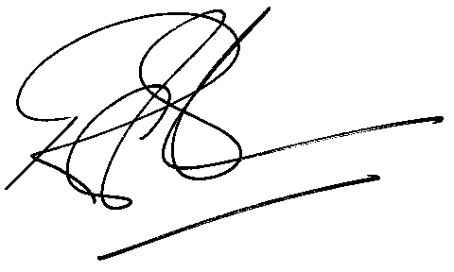
Rod Gravelet-Blondin
General Manager: Agricultural Products Division

