


JSE AGRICULTURAL PRODUCTS DIVISION

NUMBER: A295

DATE: 6 August 2003

CERES SILO AS A WHEAT DELIVERY POINT- ROAD ONLY ACCESS

Ceres silos, operated by Boland Agri (Pty) LTD, served as a delivery point for the wheat future contracts. One of the requirements to register a silo is that it be situated next to an operational rail siding. Recently the rail line servicing Ceres silo has been interrupted due to technical problems.

Ceres silo is therefore immediately delisted as a registered delivery point due to the individual silo not meeting all requirements as per Appendix D of the contract specifications.

During a discussion at a recent Agricultural Advisory Committee, a proposal was made to consider allowing silos that were previously registered, but no longer complied with the rail siding requirement due to temporary technical difficulties, to remain listed as registered delivery points whilst the rail lines were being repaired. The location differential of the silo would be increased to reflect road only transport costs. This application would be applicable only for a specified period in order for the rail line to be repaired. If the repair work was not complete within the time period the silo would be deregistered.

Boland Agri have requested that Ceres silo remain listed subject to the above conditions. Should the silo remain listed the JSE would list Ceres silo as a wheat delivery point subject to the following location differential discounts:

- R225.00 for the current marketing season and
- R265.00 for the marketing season commencing 1 Oct2003

The registration will be valid until 30 September 2004, thereafter if the rail line is still not operational the silo will be deregistered.

Please will members consult with all their wheat clients to see if the above proposal is acceptable. All comments can be forwarded to Chris Sturgess (chriss@jse.co.za) by 20 August 2003 in order to finanlise the decision. A final notice will be distributed confirming the decision by the JSE.

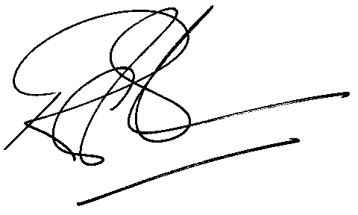
Rod Gravelet-Blondin
General Manager: Agricultural Products Division

