


JSE AGRICULTURAL PRODUCTS DIVISION

NUMBER: A303

DATE: 21 August 2003

CERES SILO WILL REMAIN A WHEAT DELIVERY POINT- ROAD ONLY ACCESS

No objections were received by the due date regarding listing Ceres silo as a delivery point with road only access. The silo will be reintroduced with immediate effect subject to the following differentials:

- R225.00 for the current marketing season and
- R265.00 for the marketing season commencing 1 Oct2003

Please note that Boland Agri has received special dispensation to continue with Ceres as a registered silo subject to the rail line becoming operational before or on 30 September 2004. Subject to failure of this requirement the silo will be deregistered.

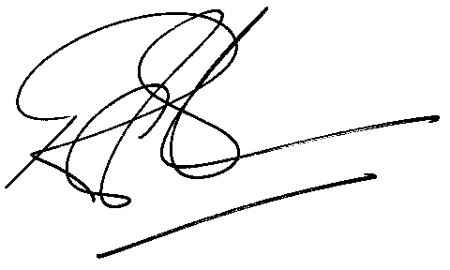
Rod Gravelet-Blondin
General Manager: Agricultural Products Division

