


JSE AGRICULTURAL PRODUCTS DIVISION

NUMBER: A309
DATE: 3 September 2003

INTRODUCTION OF MAY04 AND JUL04 CONTRACTS FOR TRADING

The May 2004 and July 2004 WEAT contracts will be introduced for trading on Monday 8 September 2003. Please be reminded that only the new grading specifications will be applicable to these contracts. The contracts will be listed although to the location differentials have not being finalised for the period after 30 April 2004.

The Jul 2004 SUNS contract will be introduced on the same day, please note NO standard storage rate or location differentials will also be applicable.

The storage rate and location differentials will be finalised later in the year.

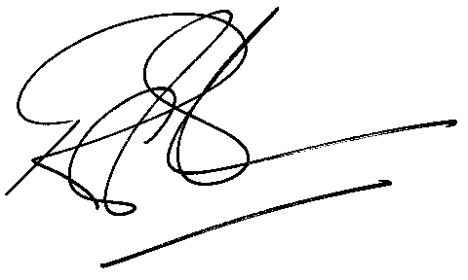
Rod Gravelet-Blondin
General Manager: Agricultural Products Division

