


JSE AGRICULTURAL PRODUCTS DIVISION

NUMBER: A319
DATE: 3 October 2003

CONSTANT MONTH SUNFLOWER SEEDS FUTURES CONTRACT

To further assist with the price discovery of sunflower seeds in the cash market, a constant month sunflower seeds futures contract will be introduced on a continuous basis. The contract will trade as per the contract specifications for a constant month contract. The November 2003 constant month sunflower seeds futures contract will be introduced on 13 October 2003 together with the other commodities.

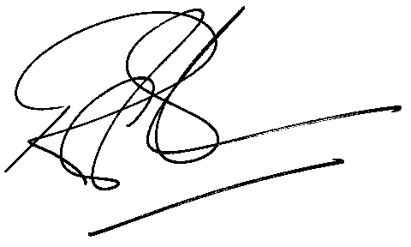
Rod Gravelet-Blondin
General Manager: Agricultural Products Division

