


JSE AGRICULTURAL PRODUCTS DIVISION

NUMBER: A320
DATE: 3 October 2003

CHANGE IN TRADING FEES

The JSE Securities Exchange embarked on an exchange wide investigation into trading fees (billing) across all markets in September of this year with the objective of ensuring a more equitable and consistent strategy across all products traded. A Billing Steering Committee examined various billing models and with input obtained from designated market participants, the billing models were discussed and agreed at the JSE Executive and JSE Board.

In regards to agricultural trading fees, the following criteria were considered:
- The moratorium on fee increases for two years as agreed in the takeover agreement between the JSE and SAFEX and the fact that fees have not increased for two years.

- The disparity between trading fees for members and trading fees for clients and the objective to remove that disparity.

- The level of trading fees in the agricultural market as compared to the financial market and international commodity markets.

It has been agreed that as from 1 January 2004, trading fees for the Agricultural Products Division will include a 20% reduction for client fees and no increase for member fees. Delivery fees will also remain unchanged.

Trading Fees applicable as from 1 January 2004. Fees include VAT

Contract | JSE APD Member  (dealing as principal) | Client
White and Yellow Maize  Future Contracts (100 tons) | R10.00/contract | R20.00/contract
White and Yellow Maize OptionsContracts (100 tons) | R5.00/contract | R10.00/contract
Wheat Futures Contracts  (50 tons) | R5.00/contract | R10.00/contract
Wheat Options Contracts  (50 tons) | R2.50/contract | R5.00/contract
Sunflower Seed Futures Contracts  (50 tons) | R5.00/contract | R10.00/contract
Sunflower Seed Options Contracts  (50 tons) | R2.50/contract | R5.00/contract
Soya Futures Contracts  (25 tons) | R2.50/contract | R5.00/contract
Soya Options Contracts  (25 tons) | R1.25/contract | R2.50/contract
Delivery Fee | R0.25/ton | R0.25/ton

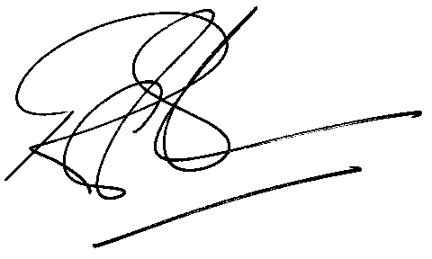
Rod Gravelet-Blondin
General Manager: Agricultural Products Division

