


JSE FINANCIAL DERIVATIVES DIVISION

NO. :A326

DATE: 20 October 2003

ATS Upgrade

There will be an upgrade of the ATS from the current Version. Full details will be forwarded to member’s closer to the date of the planned upgrade.

Members will be required to attend a community test session on Friday 28 November 2003 between 15h30 and 17h30 and Saturday 29 November 2003 between 09h00 and 12h00.

To ensure proper communication on the day, please forward the following information to Faeza Sallie at faezas@jse.co.za or fax 01-520-7199/7198

- IT contact person with direct telephone and cell numbers
- Back office contact with direct telephone and cell number
- Trading contact with direct telephone and cell number

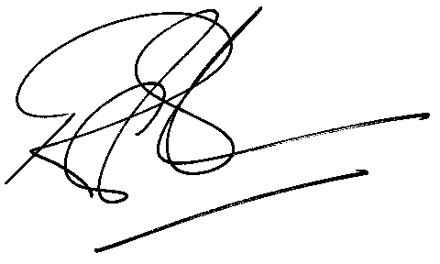
Rod Gravelet-Blondin
General Manager: Agricultural Products Division

Faeza Sallie
Faezas@jse.co.za
27-11-520-7199/7198

 |  | Name | Telephone | Cell phone
IT Contact
Dealing Desk
Back Office

