


JSE AGRICULTURAL PRODUCTS DIVISION

NO. :A327A

DATE: 20 October 2003

WHITE MAIZE POSITION LIMITS

Notice A278 dated 1 July 2003 has reference.

Members are advised that the derivatives rules to introduce white maize position limits, as attached, have been approved by the Registrar of Financial Markets in terms of section 17 (3) (b) (ii) of the Financial Markets Control Act, 1989 (Act No 55 of 1989), with effect from 22 October 2003.

These rules are effective from Wednesday, 22 October 2003. However, where members or their clients have existing speculative positions that are in breach of these limits, they will be required to reduce their exposures to ensure compliance with these rules by the close of business on the 28th November 2003.

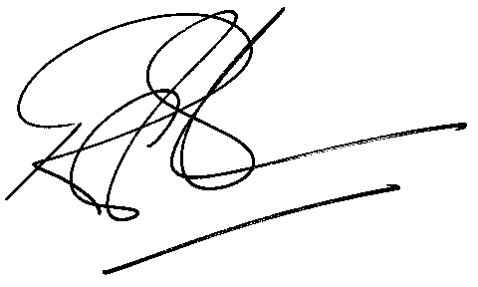
Rod Gravelet-Blondin
General Manager: Agricultural Products Division

