


JSE AGRICULTURAL PRODUCTS DIVISION

NUMBER: A330

DATE: 22 October 2003

INTRODUCTION OF FAR OUT CONTRACTS FOR TRADING

Following a request from the market, it was AGREED at the last Advisory Committee meeting to list the complete range of hedging months for the 2004/2005 marketing season. On this basis the September 2004, December 2004 and March 2005 white maize (WMAZ) and yellow maize (YMAZ) contracts will be introduced for trading on Monday 27 October 2003. Members take note that the contract will be listed with NO standard storage rate or location differentials as these will be released later in the year.

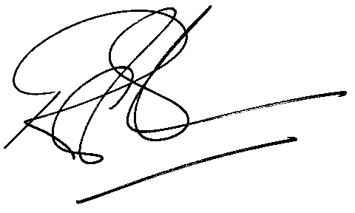

Rod Gravelet-Blondin
GENERAL MANAGER: AGRICULTURAL MARKETS DIVISION

