


JSE AGRICULTURAL PRODUCTS DIVISION

NUMBER: A342

DATE: 13 November 2003

APPLICATION BY NEW SILO OWNER – AGRISERVE

North West Agricultural Services Corporation Limited (AGRISERVE) has applied to be a JSE registered silo owner with two silos for the storage of maize, wheat and sunflower seeds. Two separate leasing agents, Kraaipan Silo Company and Difalana Merchants, will operate the individual silos, however AGRISERVE will guarantee all product issued on Safex silo receipts.

The two silos, namely KRAAIPAN and VRYHOF comply with all the JSE rules and requirements. The following location differentials have been proposed as per the different commodities for the current marketing seasons:

KRAAIPAN – MAIZE / WHEAT -R81/ton
KRAAIPAN – SUNFLOWER SEEDS -R121/ton

VRYHOF – MAIZE / WHEAT -R75/ton
VRYHOF – SUNFLOWER SEEDS -R111/ton

Please lodge any concerns or objections with regards to the listing of the above silos to the APD no later than Friday 12 December 2003. A final notice will be distributed confirming the registration.

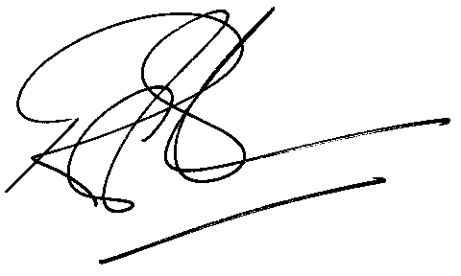

Rod Gravelet-Blondin
GENERAL MANAGER: AGRICULTURAL MARKETS DIVISION

