


JSE AGRICULTURAL PRODUCTS DIVISION

NUMBER: A345

DATE: 17 November 2003

INTRODUCTION OF MAR04, MAY04 AND JUL04 SOYBEANS CONTRACT

Following a meeting held on Friday 14 November with industry participants, it was decided to introduce the Mar04, May04 and Jul04 SOYA contracts on Tuesday 18 November for trading. Although the various expiry months will be listed, changes will be made to the underlying contract specifications in due course.

The standardised contract currently lists five silos as registered delivery points, it was AGREED in an attempt to improve the liquidity of the contract, that the number of registered delivery points be increased. A list of the additional silos will be distributed for comment before any inclusion in the contract specifications. All silos added will continue to trade at the same basis price with NO location differentials.

The standard storage rate for soybeans for the next marketing season will be 35c/ton/day.

Members please inform all clients of the above changes to the soybean contract before trading the new expiry months.

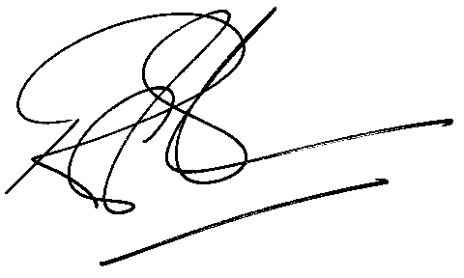

Rod Gravelet-Blondin
GENERAL MANAGER: AGRICULTURAL MARKETS DIVISION

