


JSE AGRICULTURAL PRODUCTS DIVISION

NUMBER: A459

DATE: 20 August 2004

INTRODUCTION OF FAR OUT CONTRACTS FOR TRADING

Following a request from the market, the trading months for Sunflower seeds and Soya beans will be extended

The May 2005 and July 2005 SUNS contracts and Mar 2005 and May 2005 SOYA contracts will be introduced for trading on Tuesday 24 August 2004.

The standard storage rate for both commodities and location differentials for sunflower seeds have not been finalised. Will all members please ensure that clients trading the above listed contracts are aware that NO rates apply as yet.

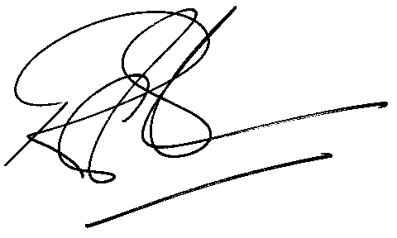

Rod Gravelet-Blondin
GENERAL MANAGER: AGRICULTURAL MARKETS DIVISION

